Field Dielectric Testing is required whenever electrical build connections (excluding connectors) are made on-site. The purpose of this Work Instruction is to provide instructions to safely perform Field Dielectric Testing using the Criterion Model AVC-25V Tester when electrical assembly of product is complete. Results of the Field Dielectric Testing should be recorded on FIELD DIELECTRIC TESTING FORM # 11181.

(1) TRAINING AND SAFETY PREREQUISITES

Ensure compliance with all Training and Safety prerequisites PRIOR to conducting Field Dielectric Testing.

Training
Prior to initiating these test instructions, ALL personnel must be informed of safety considerations and be properly trained to perform this test. Before conducting the Dielectric Test Instructions, the person performing the test must:
- understand the assembled equipment’s circuitry.
- know what First Aid procedures to follow in case of an emergency due to electrical power contact.

Safety
- Dielectric Tester will not be used without someone else in the immediate area.
- The test will not be performed while the employee is on a ladder.
- Only one person will be involved in performing the test.
- Other personnel in the area will be notified of the test.
- The area where the Dielectric Tester is being used will have a boundary set up to prevent others from making accidental contact with energized equipment.
- Only authorized personnel will be within this boundary.
- No jewelry can be worn on hands during the test.
- Workers will have approved electric safety footwear, or use an electric safety floor mat.
- All workers must not touch any part of the assembly, or anything connected to the assembly during the test, other than the tester probe and the tester controls.

(2) PREPARATION FOR FIELD DIELECTRIC TESTING

Perform the following steps in preparation for Field Dielectric Testing.

Disconnect
- All external electrical wiring connected to the equipment.
- Power Wires leading to all Ballasts and LED Drivers.
- Supply wiring and other external wiring connected to the equipment under test.
- Power Wires leading to:
- IR33’s
- SBM Boards
- CO2 Boards
- Stepper Boards
- UPS’s need to be ISOLATED and BYPASSED to ensure any circuits fed by the UPS will have continuity to the Main Power Wires and Neutral.

Connect
- All Main Distribution Wires (L1, L2, L3 in Control Panels and Chambers) and Neutral must be connected together.
- All Wires intended to operate over 30 VAC, must have continuity with the Main Power Wires and Neutral.
  - This can be accomplished by manually engaging the Coil of Contactors and Relays, switching a Connector from normally OPEN to normally CLOSED, or adding a Jumper.
  - All methods must ensure that the worker has no contact of any kind with the equipment being tested other than the Testing Probe. See photos and illustrations for examples.
- All Wires intended to operate at or less than 30 VAC, must be connected to ground.
- Most often, this is already the case because the Transformer supplying the low voltage is grounded.
- When any Transformer or Circuit under 30 volts is not grounded, a temporary connection to ground must be made for the test.
- Examples of ungrounded transformers include Argus Controllers, and Stepper Boards.

Examples of Connection Methods
These images show examples of connection methods that will ensure continuity of the high voltage circuits to the Main Power Wires without requiring the worker to use physical contact to maintain the connection.

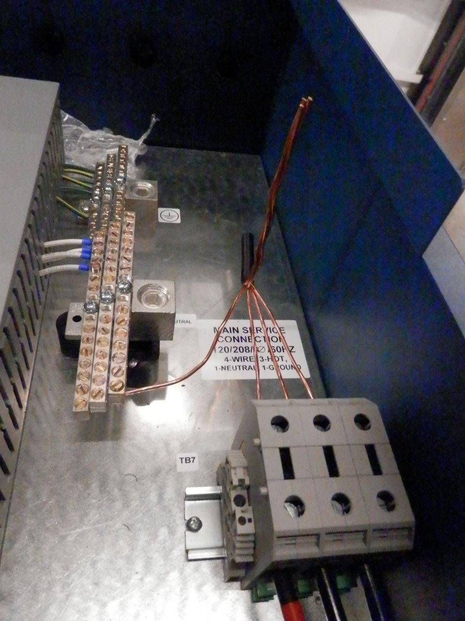
- The photo above shows thick stranded wire (i.e. 3 AWG) connecting the Main Power Wires to each other and Neutral. The Wire should be thick enough to avoid sagging and contacting the metal Control Panel Base.

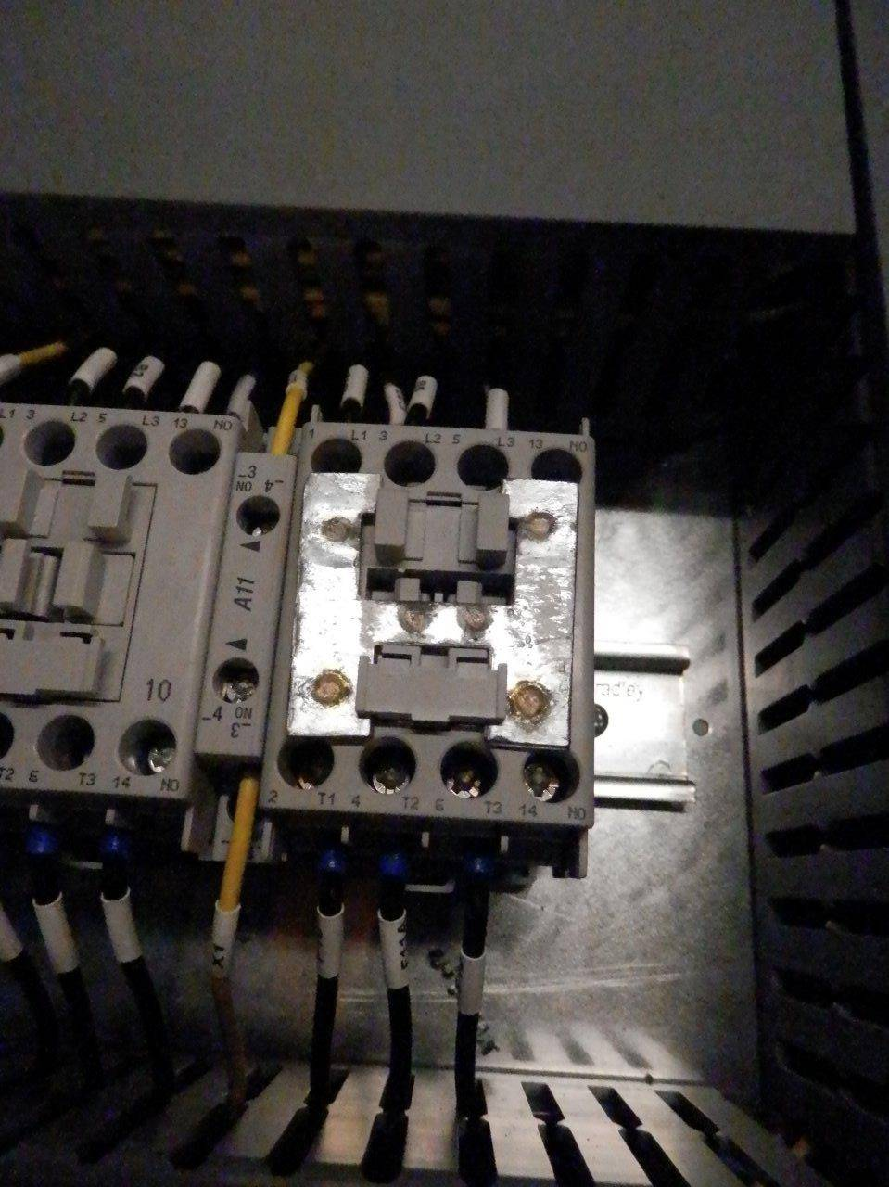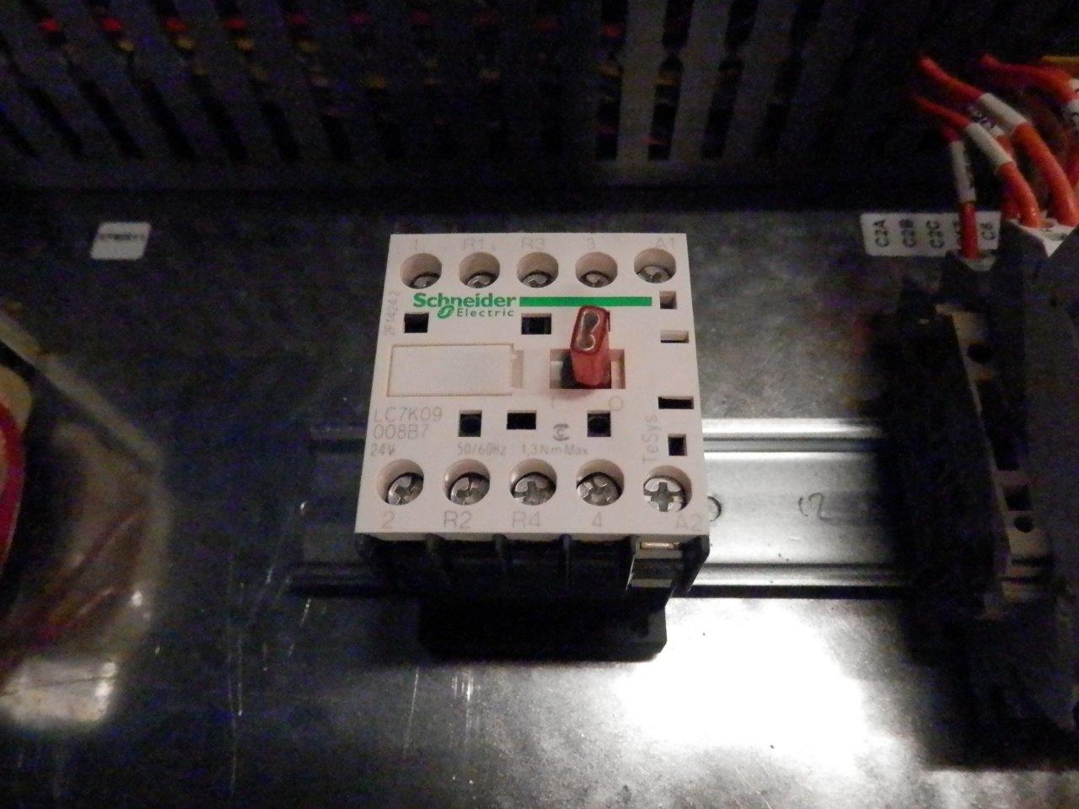
- The second and third images show how to manually engage Contactors while keeping one hand on the Probe and the other hand on the Tester’s Dial. The second image shows a Clip that is provided by Conviron, and the second shows a red push on Connector (P/N 72159) holding the Switch in the ON position.
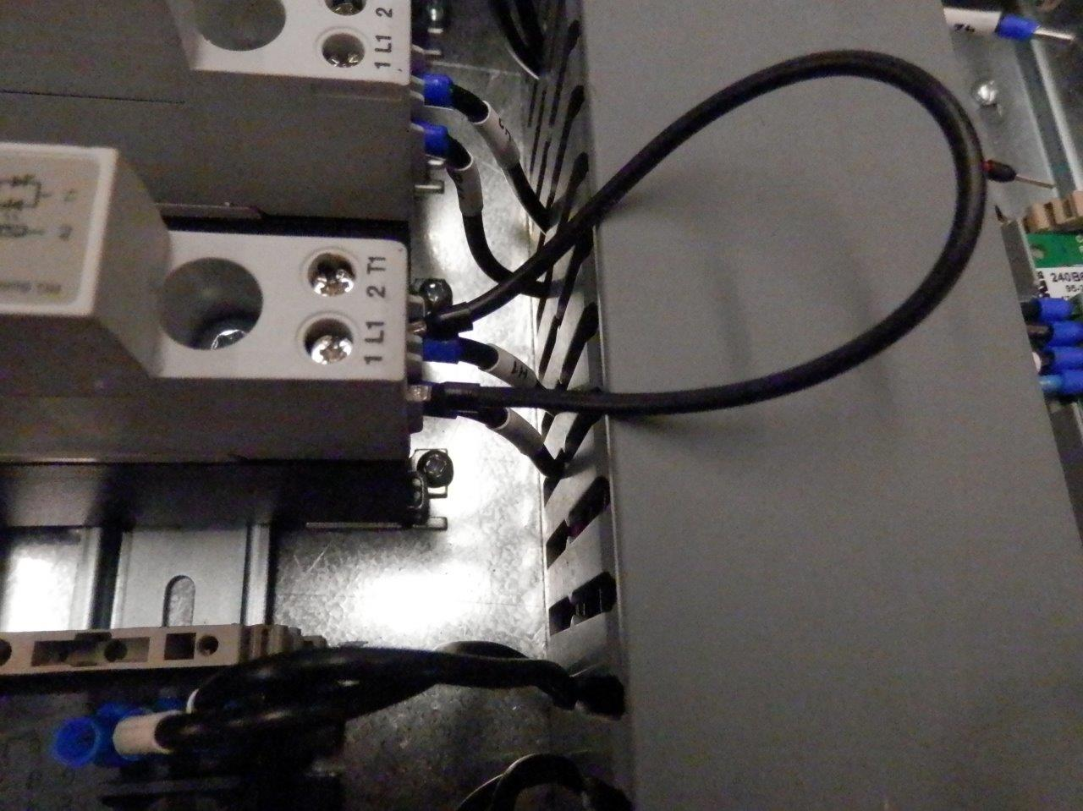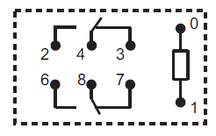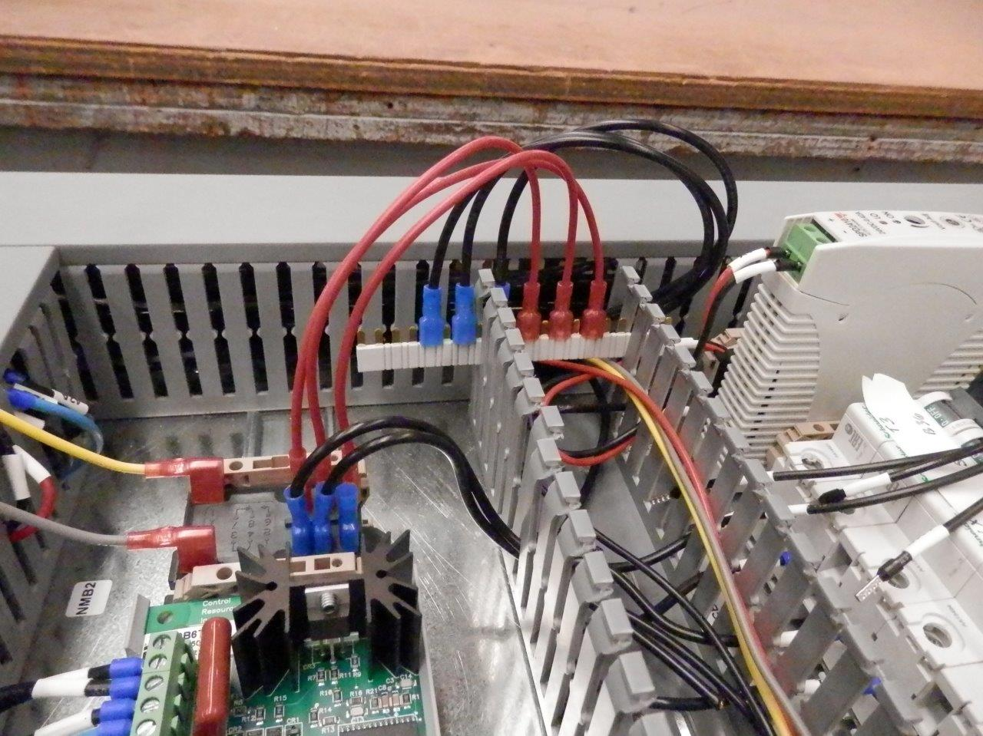
- The last 3 images show Relays that have Jumpers to provide continuity. A Solid State Relay with a simple Wire Jumper connecting the input to the output, and a Sundry Jumper (P/N 245718) that can be used if both the normally open and normally closed outputs are used at the same time.

Physical Checks
- Wire strands touching grounded metal.
- Wires jammed under screws, cut by sharp edges, improperly connected, etc.

(3) TEST CONDITIONS

Refer to FIELD DIELECTRIC TESTING RECORD #11181.
- Tests are performed for a minimum duration of 60 seconds to a maximum of 65 seconds.
- Equipment is tested at 2 times the highest rated voltage plus 1000 VAC. (Test Voltage = V x 2 + 1000).
- The highest rated voltage can be found on the Electrical List page in the schematic package.
- NOTE: Exceeding the Test Voltage or Test Duration can damage wiring and equipment.

 | Example Rated Voltages | Example Test Voltage
 | 120V | 1240V (minimum) to 1300V (maximum)
 | 208V | 1416V (minimum) to 1450V (maximum)
 | 380V | 1760V (minimum) to 1800V (maximum)
 | 480V | 1960V (minimum) to 2000V (maximum)

- Using FIELD DIELECTRIC TESTING RECORD #11181, list and record any components that were isolated from the test (to prevent component damage)

(4) DIELECTRIC TESTING INSTRUCTIONS

Confirm compliance with all requirements in (1) TRAINING AND SAFETY PREREQUISITES including that area is clear prior to initiating Dielectric Test. Ensure that steps listed in (2) PREPARATION FOR FIELD DIELECTRIC TESTING, have been accomplished and (3) TEST CONDITIONS have been properly determined. Refer to FIELD DIELECTRIC TESTING RECORD #11181.
- Move all equipment Breakers and Switches to the ON position.
- Always attach Ground Clamp from Tester to ground (ground distribution or any bare metal) on the assembly first, and disconnect this ground last.
- Connect Criterion Model AVC-25V Tester (see photo) to power supply.
- Hold Probe in one hand and continue to hold until the Tester is powered OFF.
- Turn Tester Adjustment Knob fully counter-clockwise (CCW).
- Flip Tester Power Switch ON.
- Press Tester Reset Button.
- Touch Tester Probe to the Main Power Wires and maintain contact until test duration is completed.
- Slowly increase voltage to desired level then start the required test duration.
- Note the test should always be performed by SLOWLY increasing the voltage from 0 to the Test Voltage, and back down again after the testing duration has elapsed at full voltage, rather than applying high voltage directly on and off.
- WARNING: Applying a high on/off voltage to equipment can create a surge, causing damage to equipment.
- After the test duration, slowly decrease voltage to 500 VAC.
- Touch Probe to a bare metal surface on the assembly, or the ground distribution, forcing the Tester to trip.
- If no trip occurs at this point, consider the Tester or set-up to be faulty.
- Turn Tester Power Switch OFF.
- Turn Knob fully counter-clockwise (CCW), disconnect from power and remove Test Leads.
- If the test was successful, return assembly to its pre-test state by removing any temporary Jumpers, Clips, as well as disengaging Contactor Coils and turning Relay Switches OFF.
- Record the actual test results (Test Voltage, Test Duration and Test Results Acceptable – YES or NO) on FIELD DIELECTRIC TESTING RECORD #11181.
- If a fault was found in the equipment, follow procedures listed in (5) TROUBLESHOOTING.

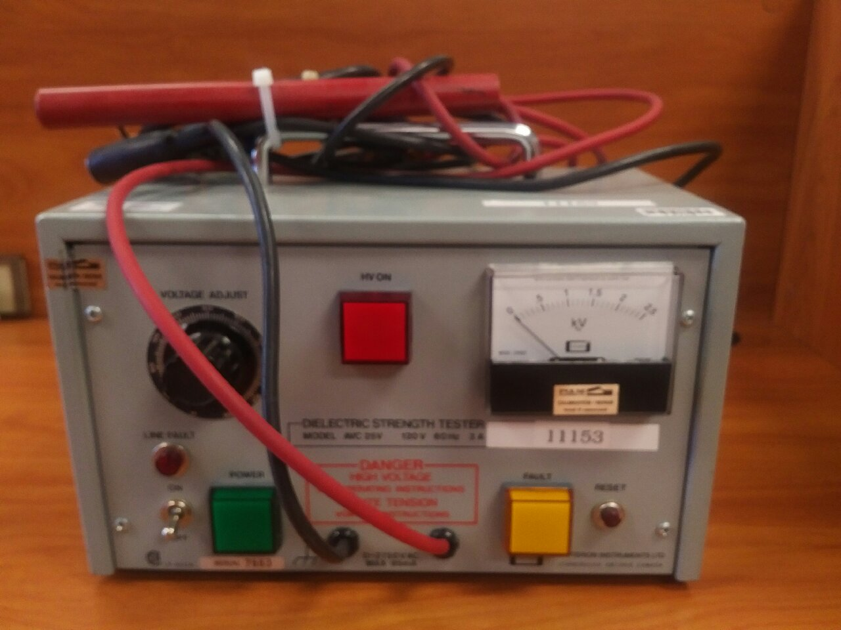

(5) TROUBLESHOOTING

Perform the following Physical Checks and Fault Isolation procedures as necessary.

Physical Checks
- Visible arcing during test.
- Carbon path may be seen if arcing has occurred.
- Neutral Bar or Neutral Wires connected to ground.
- Wire strands touching grounded metal.
- Wires jammed under Screws, cut by sharp edges, improperly connected, etc.
- Refrigeration system pulled to vacuum creating low resistance path to ground.

Fault Isolation
For this process, the dielectric voltage will use a potential of 100 VAC maximum between the test point and ground, for a maximum duration of 1 second. At this troubleshooting voltage, slowly turning the voltage up and back down will not be required.
- Remove temporary Jumpers used for the Dielectric Test.
- Turn all Breakers off and open all Fuses.
- Apply dielectric voltage to individual Power Wires, typically L1, L2, L3.
- If fault occurs, the short is in the wires or parts connected to that point.
- Apply dielectric voltage to the load side of each Breaker and Fuse.
- If fault occurs, the short is in the Wires or parts connected to that point.
- Disconnect and isolate all Neutral Wires from Neutral Busbar and each other.
- Apply dielectric voltage to each Neutral Wire.
- If fault occurs, the short is in the wires or parts connected to that point.
- Once fault has been isolated to an individual line, it may be necessary to open that circuit further to pin point the fault.

Re-Test
- Once the fault has been located and corrected, reconnect all Wires and Jumpers that were removed or separated for fault isolation.
- Repeat (4) DIELECTRIC TESTING INSTRUCTIONS.

