Field DX Refrigeration Pressure Testing is required for all Walk-In Chambers with DX Refrigeration Systems and any Reach-In Chambers where refrigeration components have been assembled on-site. The purpose of this Work Instruction is to provide instructions to safely and consistently perform the Field DX Refrigeration Testing to help ensure integrity of the refrigeration system to prevent possible leakages. FIELD DX REFRIGERATION PRESSURE TESTING RECORD #11029 shall be used in conjunction with this Work Instruction.

GENERAL INSTRUCTIONS: This test is to be performed by a qualified Refrigeration Technician. Before performing the Vacuum Test, first perform the Pressure Test to prove the integrity of joints and components. Readings are to be recorded on FIELD DX REFRIGERATION TESTING RECORD #11185.
- PRESSURE TESTING PROCEDURE: Refer to Figure 1 – Refrigeration Schematic.
  - Connect the Dry Nitrogen Distribution System to the Refrigeration System.
  - Connect the High Side Supply Line to the Discharge and Liquid Line Access Valves.
  - Connect the Low Side Supply Line to the Suction Line Access Valve.
  - Open the Service Valves where the nitrogen supply is connected.
  - Pressurize the system (low and high) to 200 psi, record pressures and wait for 2 hours to observe if there is a loss of pressure.
  - If no pressure loss is observed, mark test results as acceptable. If pressure loss is noted, test results are unacceptable. Inspect for leaks and repair as necessary. Repeat pressure test until acceptable test results are achieved.
  - Restore the system to normal by releasing pressure and removing the Nitrogen supply lines.
- VACUUM TESTING PROCEDURE:
  - Confirm Vacuum Pump operation – evacuate a Refrigerant Hose to at least 500 microns. This procedure should take no longer than 15 minutes. If you are unable to achieve 500 microns or less within the specified time, ensure Vacuum Pump has fresh oil and is operating satisfactorily. If not, replace Vacuum Pump and repeat test.
  - Pull the entire field installed system to 500 microns or less.
  - Close Refrigerant Gauge Valves in order to isolate the system from the Vacuum Pump. Let stabilize for 30 minutes. If system is dry and leak free, the micron reading should stabilize and remain at or below 750 microns after 30 minutes. Mark test results as acceptable. Otherwise, if end vacuum reading exceeds 750 microns and continues to rise, test results are unacceptable.
  - Inspect for leaks and repair as necessary.
  - Repeat Vacuum Test until acceptable results are achieved.
  - Remove Vacuum Pump.
  - Charge system with Liquid Refrigerant as required.

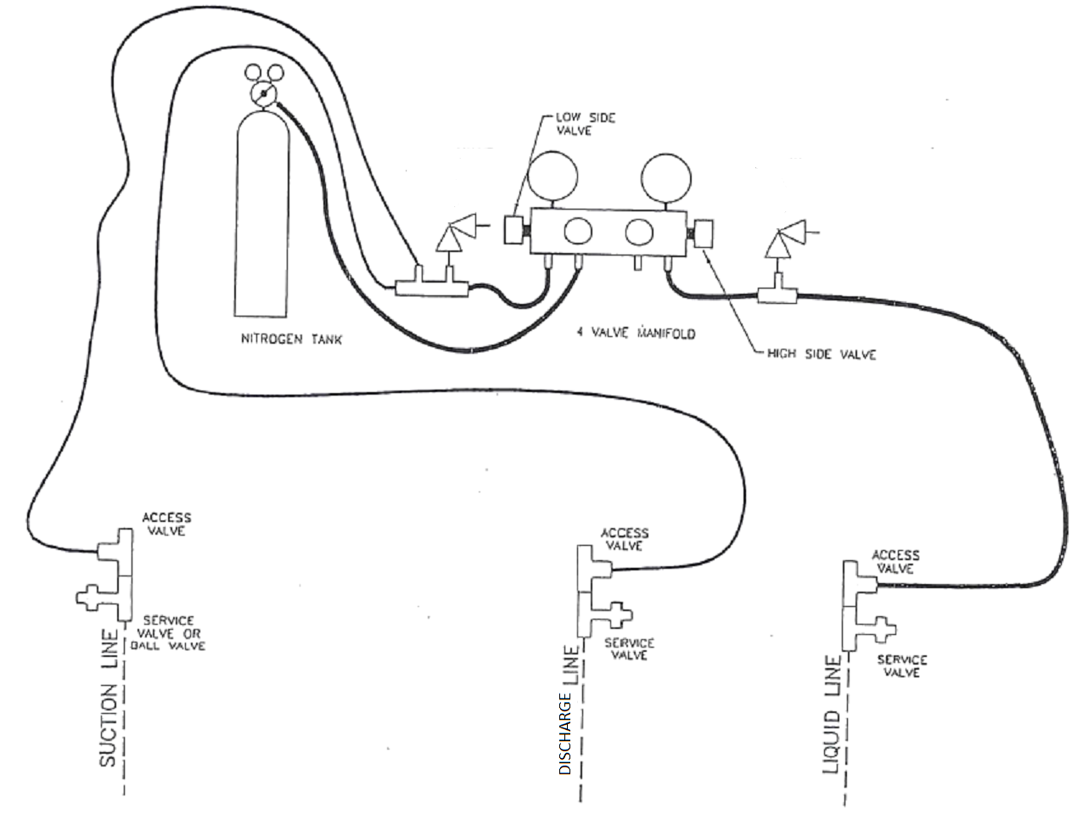

Figure 1 – Refrigeration System Schematic.

